Steps to Add a Dependency in a Maven Project

Maven repository
Repository : It is a place where maven dependencies will be stored.
we have 3 types of repositories in maven
1)Local repository
2)Central repository
3)Remote repository
1.what is Local repository ?
This Local repository will be created in our machine (.m2 folder)
2.what is Central repository ?
This Central repository will be maintained by Apache org.(public)
3.what is Remote repository ?
This Remote repository will be maintained by our company to store share libraries.

Note : to setup remote repository we will use Nexus / Jfrog software's in Realtime.

1. Open the created Maven project folder in VS Code.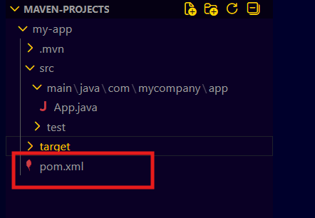

2.By default, the project contains the Dependency Management and Dependencies sections
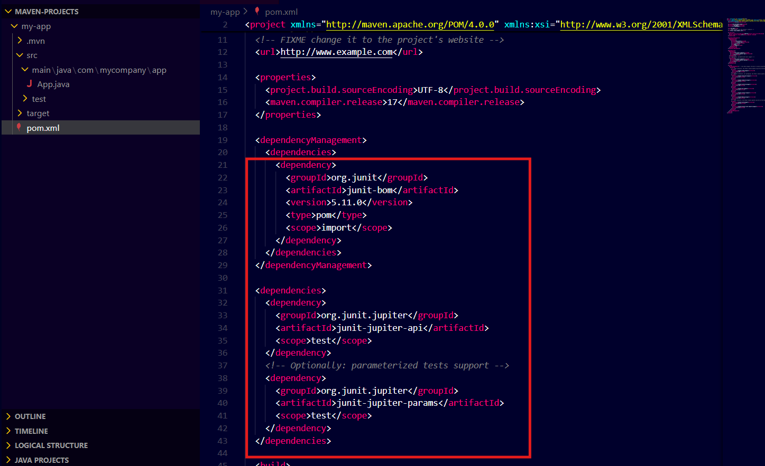
3. Maven Repository contains all necessary dependencies that we can simply copy and use in our project. (https://mvnrepository.com/)
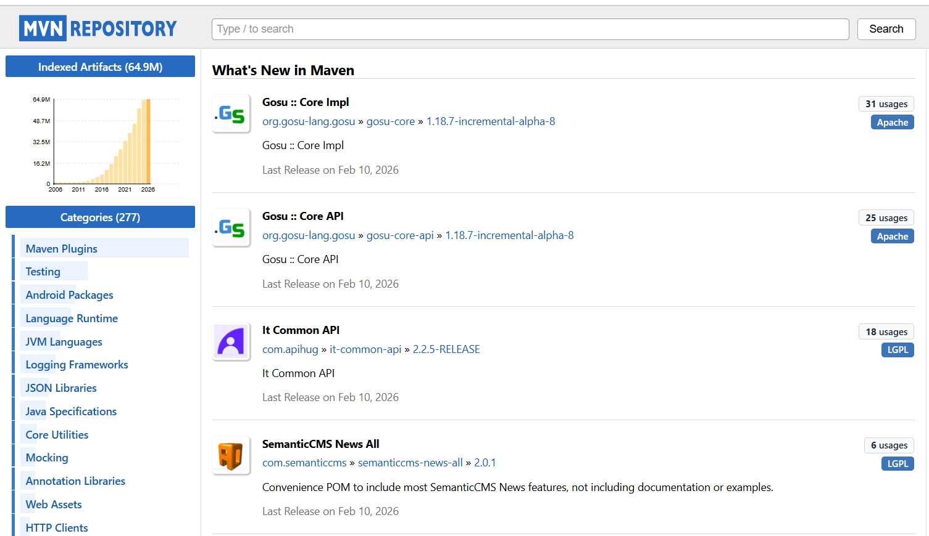

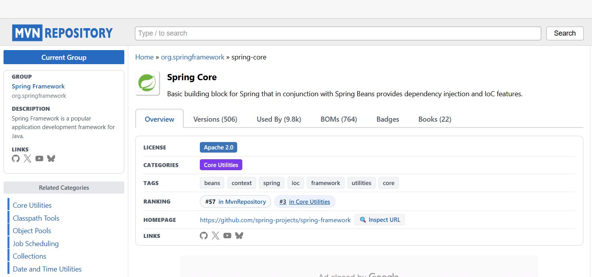
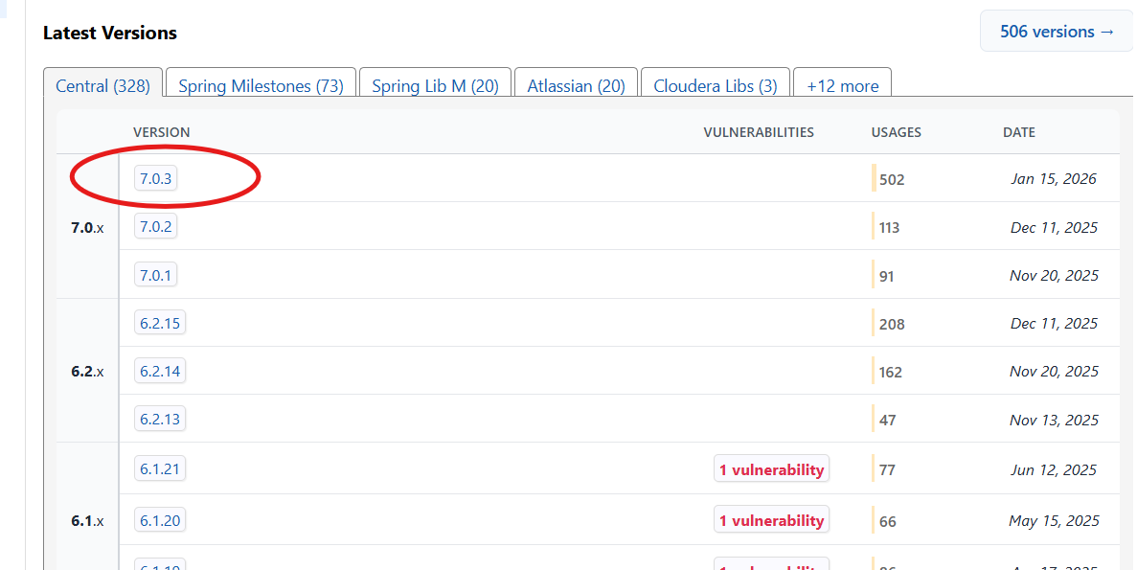
5. Select the code that is required for our tool, for example, Maven.
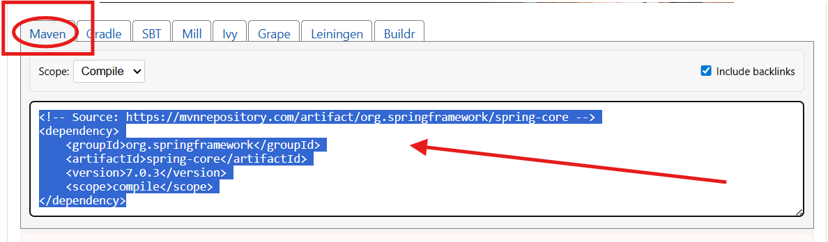

6. Paste the code into the pom.xml file in VS Code, inside the dependencies section.
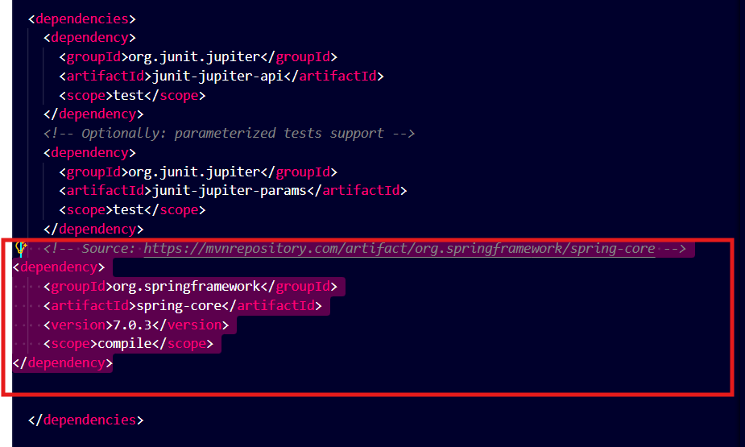

7. Run the required command to execute the Maven goal.
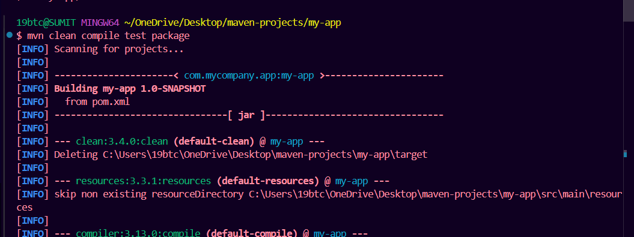
.
.

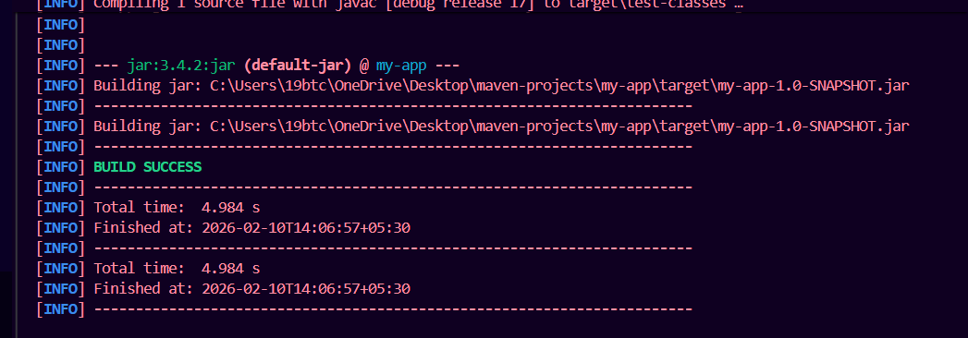
8. The new dependencies were added and the project compiled successfully with Maven Goals.

